NPC Concept Design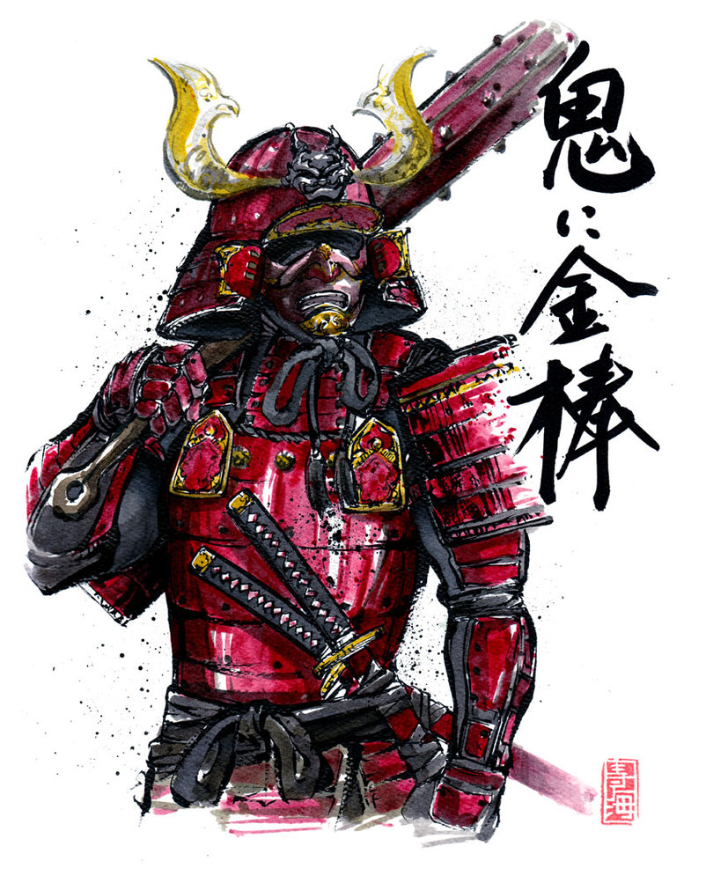

## Oni Samurai - melee

Oni are born when truly wicked humans die and end up in one of the many Buddhist Hells, transformed into Oni. They become the ogreish and brutal servants of Great Lord Enma, ruler of Hell, wielding iron clubs with which they crush and destroy humans solely for enjoyment. An oni’s job is to mete out horrible punishments such as peeling off skin, crushing bones, and other torments too horrible to describe to those who were wicked (but not quite wicked enough to be reborn as demons themselves). Hell is full of oni, and they make up the armies of the great generals of the underworld. All oni possess extreme strength and constitution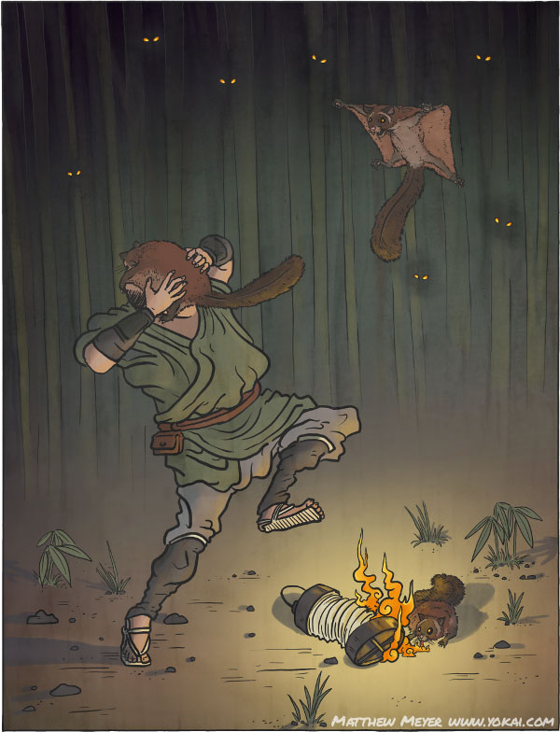

**Mechanics:** The oni walk around and hurt the player upon contact. If the player comes too near them, they stop and try to hit the player with their club.

## 

## Nodeppo - flying

Nodeppō very closely resembles nobusuma in appearance and behavior. They swoop down from trees at night, extinguishing flames. They latch on to humans’ faces, smothering them and sucking out their blood, and in many places they are considered to be the same creature.

Nodeppō also have the ability to shoot bats out of its mouth, like bullets from a gun. The nodeppō is able to spit a stream of bats out of its mouth towards the faces of its victims, blinding them in a cloud of angry bats.

**Mechanics:** Nodeppo’s can either be found flying through the level in some pattern, or can hide in trees to emerge as the player walks by en fly towards the player. They shoot bats that follow the player, maybe distort the screen on hit.

## Jubokko - AoE

On the fields of war and sites of vicious massacres, where the blood of thousands of warriors has saturated the soil, a strange kind of tree can be found. From afar, jubokko appear to be ordinary trees, indistinguishable from the various species that dot the landscape. Outwardly, they look just like ordinary trees. It takes an observant eye to notice the slightly more fearsome features of its branches, or the piles of human bones buried in the undergrowth beneath the tree. In fact, they were once normal trees, but the vast amounts of the human blood absorbed through their roots causes them to transform into yokai.

**Mechanics:** Jubo’s can’t move, but sap the life out of the player if he comes too close.